Registering Your Family and Family Members for   
Athletics at South Hills Catholic Academy

Step 1 - Register Your Family on the Website

*Skip this step if you already have a login account on the South Hills Catholic Academy Athletic Association web site.*

Go to the web site at <https://www.shcacademyaa.com/>.

Click the “Register” link at the top of the page.

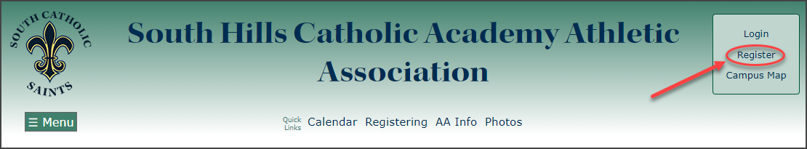

Fill out the two forms (see screenshots below) to create your Family account.

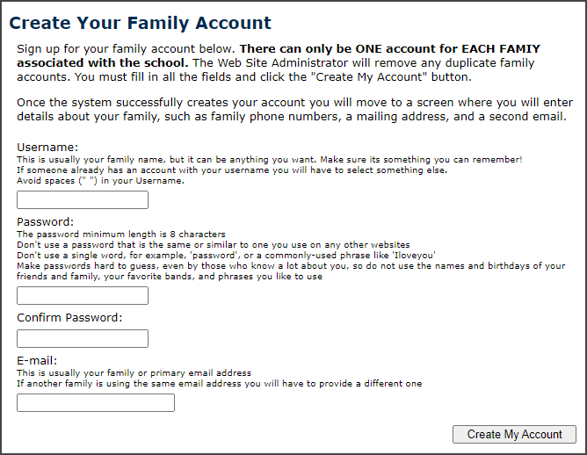

Create Account – Form 1

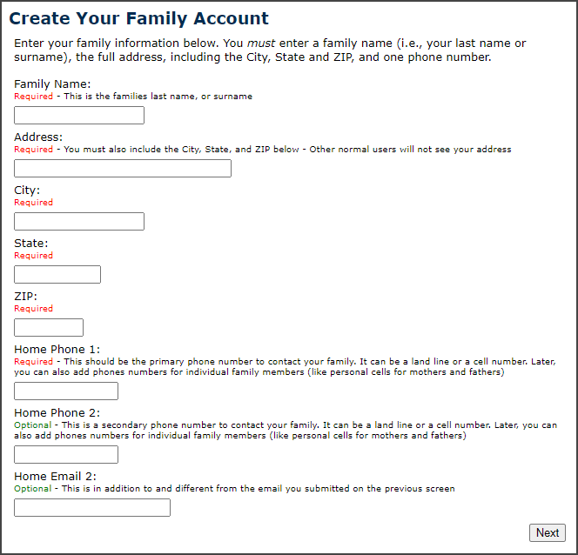

Create Account – Form 2

When you successfully create your Family account you will see a confirmation page (see the screenshot below).

Click the “Continue” button on the confirmation page.

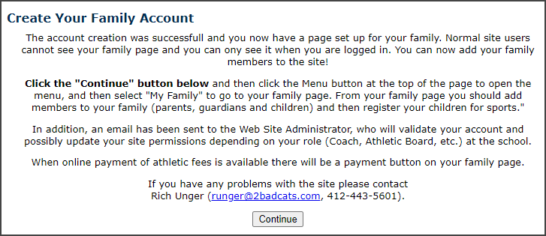

Create Account – Confirmation Screen

Step 2 - Add Your Family Members

*Skip this step if you have already added all your family members.*

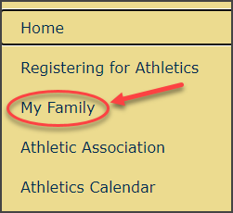Once you register your family, make sure you log in and then click the “Menu” button at the top of the page. . (Optionally, you can click the “My Family” quick link button at the top of the page)

When the menu opens, click the “My Family” menu option.

When your Family page opens click the button on the page to enter a family member.  
  
When the “Add a New Family Member” form loads fill in all the required information marked by a **\***, such as First Name, Last Name, Gender, Grade (for students), Types, Campus (for students) or Sports (for coaches)

If the family member is a student select “Student” in the **Types** list. If it is parent, select “Parent” in the **Types** list. If the parent also happens to be a coach (or wants to be a coach), select “Coach” too.

Optionally, you can enter this person's personal phone numbers and emails.

After you have entered the information about the family member click the “Add” button near the top of the page. The form will return you to your Family page. You can now add other family members.

You do not have to include Parents when adding family members unless that Parent is also a Coach. However, it is extremely helpful for the coaches to have the names and contact information for the parents. You must add students that are in the family if they want to play sports.

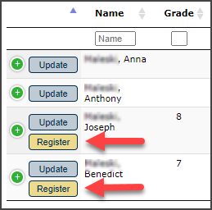Step 3 - Register Students for Sports  
  
Navigate back to your Family page if you are not there already (make sure you log in).

On the Family page, any students in the family will have a “Register” button next to their name. Click the button to go to a page to register the student for sports.

Enter the students Birthday (required), Tee-Shirt Size (required), and latest Physical Date, then select the Sports you want to register for.

When finished, click the “Update” button at the top of the page and the form will return you to your Family page.

You can go back and register students for more sports as the sports seasons progress (Fall, Winter, Spring).

If you have questions about the website contact Rich Unger, SHCA Athletic Director (412-443-5601, [runger@shcacademy.com](mailto:runger@shcacademy.com)).  
You can always go back and update your family information or the student’s sports registrations.