****Coach and Parent Duties at South Hills Catholic Academy  
Home Volleyball and Basketball Games

**Important** – the Head or Assistant Coach must open the building 45 minutes before the event and confirm that everyone has left the building before locking all doors after the events.

Starting 45 Minutes Before the Event (coaches and parent volunteers do this)

* **Coach** - unlock the doors to the Equipment, Concession and Athletic Association (AA) closets. The **AA closet** has the cash boxes (*always have someone watching the cash boxes!*), raffle tickets and bucket, scoreboard controller, spare game clock, possession arrows (basketball), linesman flags (volleyball) and game balls. The **Concession** **closet** has the concession carts, concessions and other supplies stored on its shelves.
* **Coach** - set up the scoreboard controller and retrieve the game ball – they are stored in the AA closet.
* **Coach** - set up the net before Volleyball matches. Parents are welcome to help.
* **Coach** or **Parents** - unlock one or two of the Plaza doors for players and spectators to enter. Everyone must enter through the plaza doors, so make any other doors are closed and locked. There is an Allen wrench in the drawer on the left side of the AA closet to unlock and lock the plaza doors.
* **Parents** - for extra busy events, set out the orange cones stored in the AA closest to mark the no parking area - see page 2.
* **Parents** - set up tables for the door/raffle (6-foot table stored in the stairwell at the back of the gym) and the concessions (4-foot table in the Concession closet). Chairs are in the hallways next to the girl’s restroom.
* **Parents** - wheel the concession carts into place and get other needed equipment (coffee machine, nacho cheese crock pot, etc.) from the Concession closet.
* **Parents** - if you are working the first event in a series of consecutive events, *you must SET EVERYTHING UP and start collecting door money, selling raffle tickets, or selling food and drinks 45 MINUTES before the first events start time***.** Visiting teams usually arrive at the gym **at least** 30 minutes before the start of an event.
* **Parents** - if you are working the second, third or fourth event in a series of consecutive events you need to be at your station *before* the end of the earlier event to relieve that parent.

During the Event (parent volunteers do this)

**Door/50-50 Raffle** - Your job is to collect entry fees and sell 50-50 raffle tickets from spectators before and during the event and to pay the referees

* If the referees are working a single game or match, pay them at halftime in basketball or between sets in volleyball. If the referees are working a double header (for instance, a JV/Varsity double header), pay them between the games or matches. ***Referees should not have to wait to collect money after an event.***
* The referees *must* sign the receipt book when paid.
* The referee pay scale is inside the cash box.
* For the 50-50 Raffle sell raffle tickets before and during the event. Select and announce the raffle winner at the end of the 3rd period at a basketball game or between sets of a volleyball match.

**Concessions** – Your job is to sell food and drinks before and during the event.

* Normal concessions usually include popcorn, soft pretzels, and nachos with cheese.
* Always set up the Keurig for coffee, tea, and hot chocolate.
* Extras concessions for multiple games/matches or special events may include fries, hot dogs, hamburgers, chicken fingers, walking tacos, etc. and requires extra kitchen help.

After the Events (coaches and parent volunteers do this)

* **Parents** - sweep up the gym floor and *under the bleachers*, and put everything away, including the scorekeeping equipment! Brooms are in the Janitor closet next to the women’s restroom.
* **Parents** - empty the garbage cans if they are more than half-full.
* **Parents** - make sure you turn off and clean all warmers and other devices you may have used for food. Do not forget the warmers in the kitchen.
* **Parents** - store the concessions. Put items back on the shelves in the Concession closet. Please do not just pile everything in the concession cart!
* **Parents** - store the door and concession cash boxes in the AA closet.
* **Parents** - if you used orange cones in the parking lot, bring them in and store in the AA closet.
* **Coach** – Puts away the scoreboard controller and game ball in the AA closet
* **Coach** - l**ock all the doors – this is a Head Coach Responsibility!**
* **Coach** - make sure to lock the Equipment, Concession and AA closets, turn off the scoreboard, and turn out all the lights, including those in the restrooms, before you leave the gym.

No Parking Areas and Gym Locations

During athletic events, it is important to keep the fire lane on the side of the building near the trolley tracks clear for use by emergency vehicles. Especially during busy events and tournaments, visitors tend to park along the fence at the side of the school, restricting access by emergency vehicles. If necessary, use the orange cones to delineate the no parking areas along the fence. Place the cones at least 3 feet from the fence. Make sure the cones do not restrict vehicles from using the lane and bring them in when done.

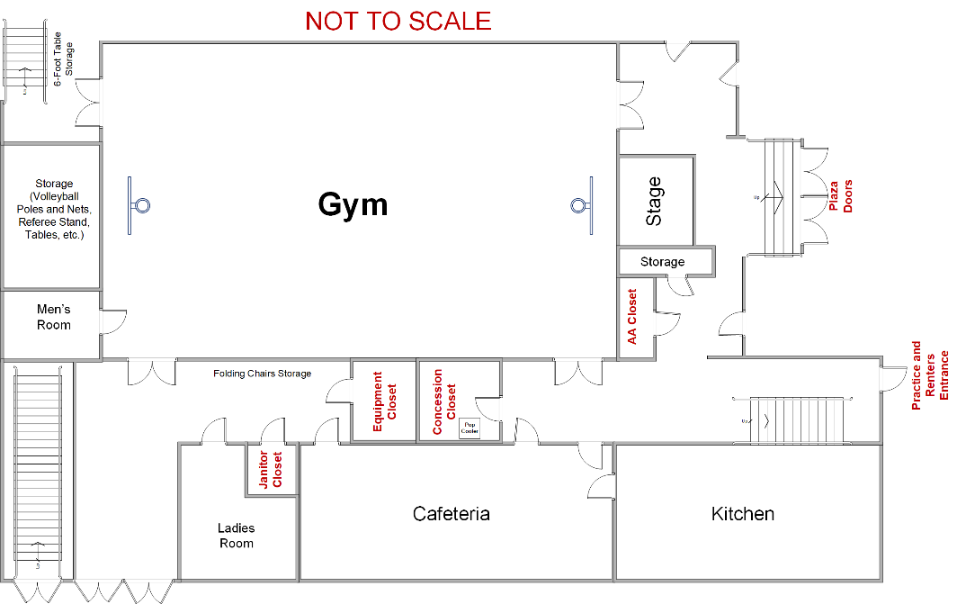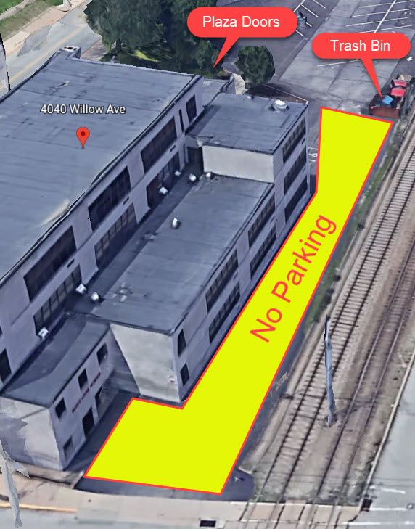

**Parents** – Collecting door money and selling 50-50 raffle tickets and concessions is crucial to supporting the athletic program. For instance, a basketball double header (JV and Varsity games) costs at least $180.00 in referee fees. Please make every effort to sell tickets and concessions. That may mean making the extra effort to bake pretzels or setting up the nacho cheese crock pot to have more options for sales.

In addition, please leave the gym in good condition after home events (clean floor, everything put away, trash emptied, etc.). *Do not leave it to the coaches to do all the cleaning!* - **Thanks**!